Shabbos Stories for
Parshas Ki Savo 5780
Volume 11, Issue 52 16 Elul/September 5, 2020
Printed L’illuy nishmas Nechama bas R’ Noach, a”h

For a free subscription, please forward your request to keren18@juno.com
Past stories can be found on the website ShabbosStories.com

L’Maaseh
For Whom Did the
Musician Play for?

Rav Yechezkel Landau, zt”l, the Rav of Prague, was known by the name of his Sefer Noda B’Yehudah. Two rich men once came to see him for an unusual Din Torah, a judgment based on Torah ideals.
What happened was that these two men lived in the same building and were good neighbors. One day, a poor musician came and stood at the door of the building and began to play some music, in order to earn a little income from donations.
The two rich men, impressed and moved by the music, began to argue, each one saying: “He’s playing for me!”
“No! He’s playing for me!”
They decided to go see the Noda B’Yehudah, for him to decide who the musician was playing for. When they approached the Rav, they each gave him 20 gold coins for spending his time to help them, and he began to hear their strange arguments.
After hearing the complaints, the Noda B’Yehudah smiled at them and said: “It was not for either of you that the musician played, but for me— so that I could merit earning 40 gold coins!”

Reprinted from a recent issue of Torah U’Tefilah as compiled by Rabbi Yehuda Winzelberg.

Judging Favorably #99
“Chapter Three”

When I learned about the idea of people being like “Chapter Three” of a continuous story, it fascinated me – and made a lot of sense. If we don’t know what went on in the previous chapter, which more often than not is the case, how can we feel sure about our condemnations?
I found that the image helped me rein in thoughts that could otherwise gallop off with more freedom than I would care to give them. I shared my enthusiasm with my family. I was hoping it would be useful for them too. I wasn’t disappointed.
One Shabbos, I was walking with my eight-year-old daughter on our quiet street when an ambulance pulled up. The back door opened and out jumped one of our neighbors.
My daughter looked at me quizzically, “Mommy, he’s not a doctor is he?” “Not that I know of, Rochy.”
We continued to walk, as we watched our neighbor go into his house.
“He doesn’t look sick, does he, Mommy?”
“He certainly doesn’t,” I answered.
“Right, Mommy,” Rochy said thoughtfully, “you can take a person to the hospital on Shabbos if he’s sick? But,” she went on, obviously in a dilemma, “you can’t ride back!” (Note: There are times when a person might be allowed, according to halacha, to return home.)
Rochy thought for a moment, then looked up at me and announced brightly, “You know what? That man is ‘Chapter Three!’ The children are listening and learning. And sometimes teaching us. (“The Other Side of the Story” by Yehudis Samet.)
Reprinted from the Parshat Shoftim 5780 email of The Weekly Vort.
The Belated Dinner
By Rabbi Yossy Gordon

Rabbi Yisrael Friedman of Ruzhin, known as the “Holy Ruzhiner” (1796–1850), once told the following parable:
“A man comes home from work at the end of the day, famished. He sits down at the table, expecting his dinner. His wife appears and tells him that he should be patient because dinner is delayed. So he waits.
“After waiting for what seems like an eternity, she places a plate before him. He takes a look, and all he sees is a hard-boiled egg and a potato. Needless to say, he is quite perturbed. Here he waited patiently although he was so hungry, and all he gets is a run-of-the-mill repast! Had he gotten something special, then he would have understood the delay. He leaves the table disappointed.
“So ends the parable,” said Rabbi Yisrael, “Now the lesson . . .
Every morning, G-d waits for His people to say their prayers. The assiduous hasten to pray, aware of the immense privilege it is to be able to address the King of kings.
“If one prays on time, then even if the prayers are not recited with the greatest concentration, the fact that they are recited on time makes them desirable to G-d. When the prayers are said a bit late, but with great concentration, G-d desires them as well, the extra devotion making it ‘worth the wait.’ However, if the prayers are late and without proper concentration, they are like the simple meal that the husband in the parable received. G-d can be expected to look askance at such an offering!”
Present was an elderly Jew who listened very carefully to the words of Rabbi Yisrael. “With all due respect, dear rebbe,” he countered, “the husband's reaction would be a harsh one if there wasn’t true harmony in the home. However, when a husband and wife really love each other, they understand when the other has a hard day. Perhaps the end of the parable should be that the husband graciously thanks his wife for the simple meal, and asks her to tell him about her day. Similarly, G-d is always ready to hear our prayers . . .”
“Indeed,” replied Rabbi Yisrael with a smile. “That is exactly the response I was hoping to hear.
“With your wise and compassionate words, you have saved many of your brethren from harsh judgment. It was for this purpose that your soul came down to this world.”

Reprinted from the Parshat Ki Seitzei 5780 email of Chabad.Org Magazine.

The Gentile and the Jew

Rabbi Chaim Palagi, of blessed memory, related that anything his grandfather did, or taught others to do, was based on a source in the Torah, relating the following story about his grandfather. A Jew and a gentile came before Rav Chaim’s grandfather to adjudicate a monetary dispute. The gentile claimed that the Jew had borrowed money from his, but the Jew denied that he owed him anything. Rav Chaim’s grandfather sensed that the gentile was truthful.
After hearing the arguments on both sides, he told them that he had to leave for a few minutes, and asked them to discuss the matter between themselves in the meantime. The din Torah (case) was held in the local beis medrash (study hall), and the two litigants thought that the judge left the beis medrash, but the judge went up to the women’s section and was listening to every word the litigants were saying.
A heated argument erupted between them, and Rav Chaim’s grandfather heard the gentile shouting at the Jew, “Aren’t you ashamed? You know very well that you borrowed money from me, and how can you claim that you don’t owe me anything?”
“Yes, I borrowed money from you,” the Jew said, “but I’m in a lot financial stress right now; I don’t have the money to pay back.”
Rav Chaim’s grandfather went back down into the beis medrash and ruled in favor of the gentile, rebuking the Jew for his contemptible behavior. He later explained that he derived the strategy of leaving the litigants alone and listening in to their conversation from the verse in our portion (Devarim 1:16), “listen among your brethren and judge righteously.”

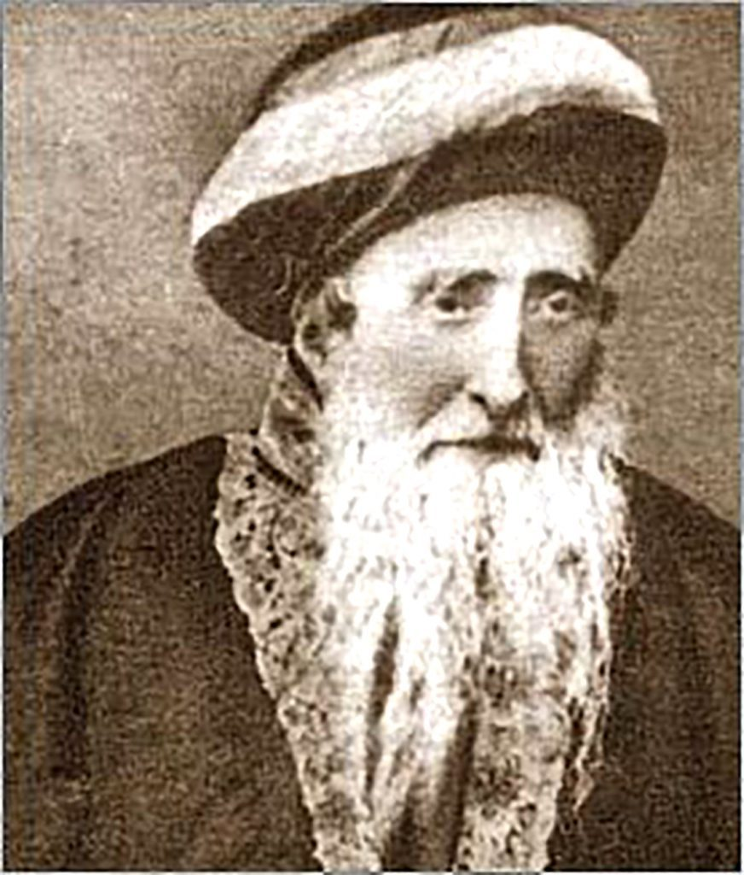
Illustration of Rav Chaim Palagi, zt”l

The simple meaning is that a judge has to listen to both sides equally, and not give preferential treatment to one. However, the Rav saw that the verse implies that one should listen “among your brethren,” what the litigants say to each other, in order to arrive at the proper verdict.
Comment: Rav Yitzchak Zilberstein (in Aleinu L’Shabeyach) tells this story to drive home the point that everything we need to know is written in the Torah. Fortunate is one who bases his conduct and lifestyle on the Torah’s teachings.

Reprinted from the Parshas Devorim 5780 email of Torah Sweets Weekly.

The Klausenberger Rebbe And The Non-Religious Banker

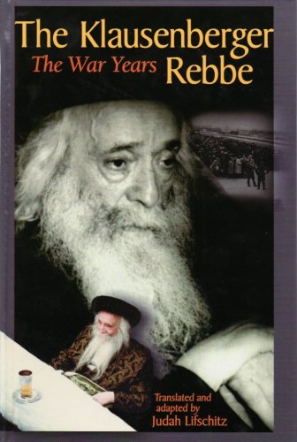

Taken from the book “The Klausenberger Rebbe: The War Years” (translated and adapted by Judah Lifschitz).
In 1983, while speaking to this student of Bet Chana in Williamsburg, the Rebbe told, in details, the following personal experience:
“In the camps, we were forced to sleep on the floor. Forty-two people were stuffed into a small room, and within two weeks only I and one other person were left alive. The other forty had died from starvation and disease. This other man, who came from Budapest, and I slept on the ground, enveloped in darkness and surrounded by insects and rodents.
“‘Are you Jewish?’ I asked my companion.
“‘Of course! Why else would I be here?’ he answered.
“‘Who are you?’ I probed.
“‘I am the president of the National Bank of Hungary.’ This was the most important finance position in Hungary; it meant that this man’s picture appeared on all Hungarian currency.
“‘I asked again, ‘Are you Jewish?’
“This time he answered, ‘No.’
“‘Didn’t you just say that you were?’ I queried in surprise.

The Jew Who Converted to Christianity
“The man quickly explained himself: ‘I converted to Christianity!’ Clearly he had abandoned the faith of his ancestors in order to move up society’s ladder.
“It was impossible to fall asleep, so I continued the conversation, gazing pityingly at him. ‘Are you married?’
“‘Yes, but my wife is a Christian,’ he answered.
“‘And she did not join you here?’ I asked with mild astonishment.
“Angrily, the man responded, ‘How could you even think of such a thing? Why should she have come here? To suffer as much as I am?’
“Innocently, I responded, ‘I do not understand. Doesn’t a good devoted wife follow her husband wherever he goes, even to Gehinnom if necessary? Would a good wife leave her husband alone in this state?’ Without pausing for breath, I continued, ‘Tell me, did you live well?’

What Kind of Question is That?
“‘What kind of a question is that? In the thirty years we lived together, I bought her the best of everything. I gave her all the good in the world!’
“‘If so, I am really shocked,’ I said. ‘How is it possible that you treated your wife so well for thirty years, and she is only willing to share the good times with you? In hard times like this, she leaves you to deal with it alone?’
“We stopped talking then. The night passed and in the morning we were called to work again. The next night, I struck up a conversation again. ‘Tell me, did you accomplish important things for the Hungarian government?’
“‘Certainly,’ the former banker responded. ‘When I was hired to manage the National Bank, the economy was very depressed. The forint’s value had gone way down. With one thousand forints you could hardly buy anything. I made it into a real currency, a strong currency. Hungary became prosperous, thanks to my hard work, and it began to trade with the whole world. I accomplished great things in the fields of finance and business. You never heard of me?’
“I shrugged my shoulders apologetically. ‘I am not involved in such matters. I am not a businessman or a banker.’
“The banker asked in surprise, ‘You really mean you don’t know who I am and what I was? To this very day you won’t find a single gentile in Hungary who doesn’t recognize my name.’

How is that the Hungarian Nation
Did Not Protest Your Arrest?
“Then how is it that you were sent here, and the Hungarian nation did not protest? After all you did so much for them. How could a person as important and as accomplished as you be run out of the country and into a concentration camp without any legitimate reason?’
“‘Why are you provoking me so much?’ the banker exploded. ‘Perhaps you can tell me why you are imprisoned here?’
“‘I am just a poor rabbi,’ I answered. ‘I never did anything for a gentile. I never even gave one of them a glass of water. They hate me. But you did so many good things for them. How can they hate you? I would expect them to carry you on their shoulders, not send you to a concentration camp.’
“‘Well, as you can see they did not carry me on their shoulders.’
“‘I simply cannot understand it. After all, you converted to Catholicism and became a complete non-Jew in order to be like them and to be accepted by them – and they ignored it all.’ As aside, I asked, ‘What about your children? What do they do?’
“‘My children? One is a doctor, the other a lawyer, and the third a successful businessman.’
“‘Did you also provide for them?’

Sent His Children to the Best Schools
“‘Of course!’ the banker answered. ‘I sent them to the best schools so that they would be well educated.’
“‘And why did your children not come after you?’ I pressed. Even when a person dies his children follow the casket to the cemetery. Your children have left you to be exiled in shame…. They didn’t follow you to the border. Not a single one has come here to see where their father is and what is happening to him.’
“‘You are hurting me very much with your worlds. You want to annoy me.’
“‘I don’t want to annoy you, God forbid I just want to understand how bitter your situation is.’
“We continued talking until late at night. My words began to penetrate the assimilated banker, for on the third night, he initiated the conversation. ‘You know, Rabbi, I’ve been thinking about your words all day… I have come to the conclusion that you are right!’ He expressed genuine regret for having converted, for having married a non-Jewish woman, even for spoiling his children so much. The banker saw clearly that absolutely nothing from his pathetic life remained with him. ‘I made a mistake,’ he cried in a choked voice. ‘I made a terrible mistake with my life.’
‘On the fourth night, the banker was no longer among the living. I was grateful for the opportunity that had been sent my way. He had at least done teshuvah and regretted his deeds a day before his death.”

Reprinted from the Parshat Vaet-hannan 5780 email of Rabbi Amram Sananes as written by Jack E. Rahmey.

The Happy Confidence
Of Rav Simcha Zissel

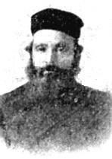
Rav Simcha Zissel Broida [the Alter of Kelm, 1824-1898 and early leader of the Mussar movement], It was Erev Yomtif and [his wife] hadn’t shopped at all. There was no money in the house. He had a family. The wife was also very pious, but she was looking at him. And he was looking at Hakodesh Boruch Hu [the Holy One blessed be He].
He [Rav Simcha Zissel] was walking back and forth in the house and humming a nigun. I’m sure the words were something like this: Ashrei adam oz lo bach – Happy is the man whose strength is in You. He was walking back and forth and humming those words. If his wife was humming, I don’t know – that’s not mentioned in the story – but I’m sure that she had confidence too.
And then all of a sudden, a letter comes from America just before Yomtif with a big banknote and it was enough to cover everything.

Reprinted from the Parshas Shoftim 5780 email of Toras Avigdor based on Rabbi Avigdor Miller’s Tape #31 (“Hashem is King.”

Story #1185
The Apartment Next Door
From the desk of Yerachmiel Tilles
editor@ascentofsafed.com

Rabbi Yossel, an emissary of the Lubavitcher Rebbe in a town in Israel, followed the Chabad custom to have his mezuzot and tefillin inspected once a year, during the month of Elul. In Elul 5749 (1989), R. Yossel brought his tefillin and mezuzot as usual to the home of a scribe. Every single mezuza was found to be kosher. Satisfied and relieved, R. Yossel took the mezuzot home and re-affixed them on his doorways.
As an emissary of the Rebbe, Yossel wrote regular reports to the Rebbe. In his weekly letter, Yossel reported on the preparations that his community was making towards the upcoming Rosh Hashana holiday, and mentioned that his mezuzot had been checked and were found to be kosher.
The month passed quickly in a whirl of activity. Yossel barely had a moment’s rest as he ran around carrying out his communal duties, helping his congregation prepare for the holidays. After all his dashing about, Yossel was not surprised to find that his feet were aching, although this was unusual for him.

The Pain Intensified and Became Difficult to Walk
The pain intensified to a stabbing, throbbing ache. As the days went by, walking became more difficult for Yossel and he realized that he could ignore the situation no longer. He hobbled to the doctor who inspected the foot and told Yossel that he had a serious infection. The doctor prescribed therapeutic soaks, cream and antibiotics. He cautioned Yossel to let his feet air out and stay off his foot until it healed.
Rosh Hashana arrived, and Yossel could barely drag himself to shul. Every step was agony. Instead of leading his congregation in prayer, Yossel was forced to stay seated the entire time with his feet elevated. His condition worsened as the infection did not respond to any treatment.
On the day after Rosh Hashana Yossel was once again in bed, being examined by his close friend a doctor. The infection is very serious and has penetrated deep inside your foot. If it doesn’t begin to subside, the foot may have to be amputated.

What More Could Be Done?
What more could be done? They had already tried everything. Yossel’s wife decided to fax a letter to the Rebbe. Generally, Yossel believed in not being a “fair-weather friend” and writing to the Rebbe only when there were problems. He preferred to report only positive news to the Rebbe [1] which was why he had not written yet about his foot. But now there was no other option.
He gave the letter to his wife to fax, but before she had a chance to do so, they received a phone call from the Rebbes secretary. The Rebbe instructs you to check your tefillin and mezuzot, and he will mention you in his prayers at his father-in-law’s gravesite.
Yossel’s first thought was, my mezuzot were just inspected last month. What could the Rebbe mean? After a short consultation with his wife and children, they came up with a possible explanation.
The family lived in an apartment building. The apartment next door belonged to a friend who had moved out. Before leaving, the friend had handed the keys to the empty apartment to Yossel and told him that the apartment was his to use for his Chabad activities, free of charge. Yossel was surprised and grateful for this generous offer.
The friend moved out, taking all the contents of the apartment with him, including the mezuzot. Yossel set up the apartment as his office and put up plain mezuzot ,since he was not sure if, according to Jewish law, he was actually responsible for maintaining mezuzot on the apartment. Because of the Rebbe’s instruction, Yossel decided to take down all the mezuzot in his office and have them inspected.
Two weeks later, during the holiday of Sukkot, R. Yossel received a call from the scribe. The mezuzot were checked, and all were found kosher except for the one on the doorway leading to the porch. Yossel’s wife ran out to purchase a new mezuzah and then attached it properly in place.

“Happened Upon” an Article
About a Simple Natural Remedy
That same day, she “happened upon” an article in a medical journal that described a simple, natural remedy for the infection her husband had. Yossel was incredulous--could such a simple method help his foot, after he had already used the most powerful antibiotics? Still, it was worth a try.
Wonder of wonders, as soon as Yossel applied the salve, the infection began to subside. Within a day, his foot was completely healed.
The following day was Simchat Torah, and Yossel gave his congregation a most pleasant surprise, when he walked in on two healthy feet to dance with the Torah together with his community.
Source: Adapted by Yerachmiel Tilles from Geulah #62 (Nov. 2005).
Connection : Seasonal - the Jewish month of Elul, the 30 days before Rosh Hashana.

[1] Actually, the Lubavitcher Rebbe made it clear that he expected to receive both.

Reprinted from the Parshat Ki Seitzei 5780 email of KabbalaOnline.org, a project of Ascent of Safed.

The Greater Rebbe’s Brocha

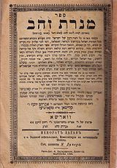
Book by Rabbi Zishe of Hanipoly, "Menorat Zahav" (Candelabra of Gold). Edition from 1902

A man would visit his Rebbe – R’ Zishe of Hanipoly every year during the month of Elul, and receive a brocho for the coming year which produced, to his mind, a satisfactory though not extraordinary year.
One year, when he arrived in Hanipoly, he found that R’ Zishe was away, and upon inquiry discovered that R’ Zishe had gone to see his Rebbe to receive a brocho for himself.
The man thought about it and reasoned that if he also went to R’ Zishe’s Rebbe for a brocho, he could only imagine how much better it would be for him. So he did exactly that, received the brocho he desired, but the following year’s Hatzlacha did not turn out as well as that of previous years.
Returning to R’ Zishe the following Elul, he described what he had done and asked why the brocho of the “greater” Rebbe had not been so great.
R’ Zishe explained to him that on Rosh HaShanah, as each person passes before Hashem’s judgment, all his details are displayed. If he is one of R’ Zishe’s followers, Hashem has increased Rachmanus for him and as such, is willing to “overlook” and forgive his conduct.
However, when someone thinks he may be deserving of a bigger brocho and goes to the greater Rebbe for it, he is scrutinized more carefully, and may be found wanting.

Reprinted from the Parshas Ki Seitzei 5780 email of the Pleasant Ridge Newsletter.
True Empathy

R’ Refoel Levine, the son of the renowned tzaddik, R' Aryeh Levine, was a remarkable tzaddik in his own right. Like his father, his tziddkus was most evident in his tremendous concern and love for his fellow Jews, especially those who were in need of support and encouragement.
One Motzei Shabbos, R’ Refoel was walking to the Kosel with a talmid when a man approached him to say hello. R’ Refoel answered him and asked him how his wife and children were doing.
Apparently the man's family life was a difficult one because he spent the next few hours pouring his heart out. R' Refoel listened intently the entire time, and offered the man words of comfort.
He sent him off with heartfelt brachos, and sent regards to his family. He reassured the man that he was davening for him as he said goodbye.
R’ Refoel's talmid was curious about who this man was, after seeing how much time the rabbi had devoted to him. "Who was that man?" he asked.
R' Refoel responded, "I don't know. This is something I learned from my father. If someone greets you as if he recognizes you, you should respond to him in the same way."

Reprinted from the Parshas Ki Seitzei 5780 email of Migdal Ohr.

